DAY – 5
IN GET DATA USING UNLIMITED DATABASE LIKE ORACLE OR SQLSERVER WE HAVE TO CONNECTIVITY MODE:
- IMPORT – GET THE COPY OF THE SOURCE DATA IN POWER BI AND MANUAL REFRESH
- LIMITED STORAGE
- IMPORT FASTER BECAUSE INMEMORY PROCESS
- Even if the database is shut down, you can still see the data, but you can’t refresh it until the database is back online.

- DIRECT QUERY – DIRECTLY FROM DATABASE WHICH DON’T DEPEND ON POWERBI STORAGE,
UNLIMITED STORAGE
IT HIDDEN TABLES SECURITY INCREASE
AUTO UPDATED
- IN TRANSFORM DATA WE CAN SEE DATA
ITS LITTLE SLOWER BECAUSE DATA SOURCE PROCESS
If the database is shut down, Power BI will show an error when it tries to access data, like:
"Unable to connect to the database" or "Data source not reachable."
The data will not be shown, but it is not "removed" it simply can’t be fetched because the source is down.
- Some FUNCTION WONT SUPPORT LIKE DAX ETC IN DIRECT QUERY

- DUAL MODE: IF WE USE BOTH IMPORT AND DIRECT QUERY IN SINGLE REPORT WE CALLS DUAL MODE
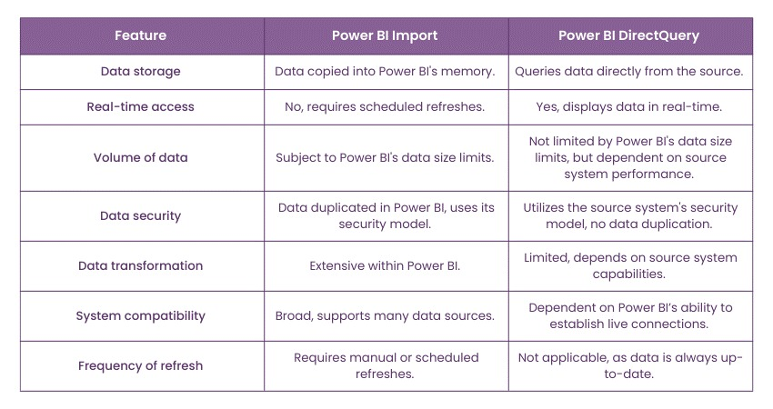

DAY – 6
IMP: DIRECT QUERY DATA TABLE IS INVISIBLE BUT WE CAN SEE DATA IN POWER QUERY EDITOR THRU TRANSFORM DATA
BEFORE LOADING WE HAVE PRE PROCESS IS CALLED TRANSFORM DATA IT REDIRECT TO POWER QUERY EDITOR.
IN POWER QUERY EDITOR AND EXCEL BACKEND PROGRAMMING LANGUAGE IS M(MICROSOFT) LANGUAGE

